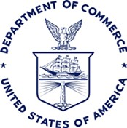

U.S. INVESTMENT ADVISORY COUNCIL MEETING
Thursday, May 11, 2017 | 9:30 – 11:30 AM
Department of Commerce| Washington, DC

- Welcome
Chair Jane Garvey and Vice Chair Catherine Smith

- Opening Remarks
The Honorable Secretary Wilbur Ross, U.S. Department of Commerce

- A Perspective from the White House
Jeremy Katz, Deputy Assistant to the President and Deputy Director of the National
Economic Council, The White House

- Discussion of Priorities, Deliberation of Recommendation Letter,
& Next Steps
Lead by Chair Jane Garvey and Vice Chair Catherine Smith

- Closing Remarks
Fred Volcansek, Executive Director of SelectUSA, U.S. Department of Commerce

- Adjournment
Chair Jane Garvey

